**Relaxation Exercises**

Calm Mind Strategy

Mountain Breathing

1. As you inhale through your nose, raise your arms up and place your hands together over the top of your head.  ​
2. Imagine that you are as tall as a mountain.  ​
3. As you exhale, bring your palms down in front of your chest.  ​
4. Repeat this process 5 times.

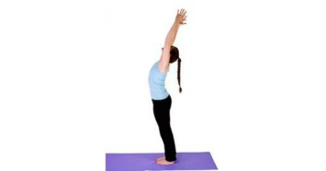

[This Photo](http://www.beautyglimpse.com/10-best-yoga-poses-grow-taller/) by Unknown Author is licensed under [CC BY-NC-ND](https://creativecommons.org/licenses/by-nc-nd/3.0/)

